**Here is the HTML source code for the image map above:**

<!DOCTYPE html>

<html>

<body>

<h2>Image Maps</h2>

<p>Click on the computer, the phone, or the cup of coffee to go to a new page and read more about the topic:</p>

<img src="workplace.jpg" alt="Workplace" usemap="#workmap" width="400" height="379">

<map name="workmap">

<area shape="rect" coords="34,44,270,350" alt="Computer" href="computer.htm">

<area shape="rect" coords="290,172,333,250" alt="Phone" href="phone.htm">

<area shape="circle" coords="337,300,44" alt="Cup of coffee" href="coffee.htm">

</map>

</body>

</html>

**Images**

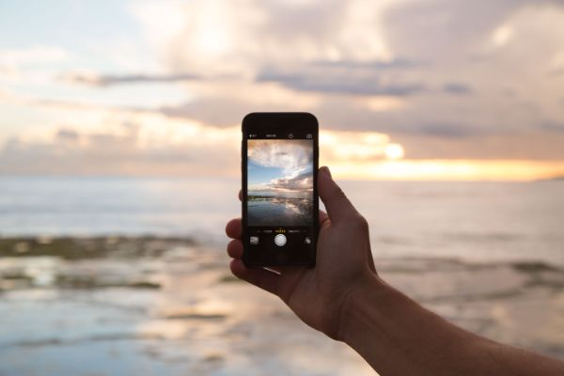

coffeehouse2.jpg

cellphone.jpg

mac.jpg

workplace.jpg

Create Image Map

Then, add a <map> element.

The <map> element is used to create an image map, and is linked to the image by using the required name attribute:

<map name="workmap">

The name attribute must have the same value as the <img>'s usemap attribute .

The Areas

Then, add the clickable areas.

A clickable area is defined using an <area> element.

Shape

You must define the shape of the clickable area, and you can choose one of these values:

* rect - defines a rectangular region
* circle - defines a circular region
* poly - defines a polygonal region
* default - defines the entire region

You must also define some coordinates to be able to place the clickable area onto the image.

Shape="rect"

The coordinates for shape="rect" come in pairs, one for the x-axis and one for the y-axis.

So, the coordinates 34,44 is located 34 pixels from the left margin and 44 pixels from the top:



The coordinates 270,350 is located 270 pixels from the left margin and 350 pixels from the top:



Now we have enough data to create a clickable rectangular area:

Example

<!DOCTYPE html>

<html>

<body>

<h2>Image Maps</h2>

<p>Click on the computer to go to a new page and read more about the topic:</p>

<img src="workplace.jpg" alt="Workplace" usemap="#workmap" width="400" height="379">

<map name="workmap">

<area shape="rect" coords="34,44,270,350" alt="Computer" href="computer.htm">

</map>

</body>

</html>

This is the area that becomes clickable and will send the user to the page "computer.htm":



Shape="circle"

To add a circle area, first locate the coordinates of the center of the circle:

337,300



Then specify the radius of the circle:

44 pixels



Now you have enough data to create a clickable circular area:

Example

<!DOCTYPE html>

<html>

<body>

<h2>Image Maps</h2>

<p>Click on the cup of coffee to go to a new page and read more about the topic:</p>

<img src="workplace.jpg" alt="Workplace" usemap="#workmap" width="400" height="379">

<map name="workmap">

<area shape="circle" coords="337,300,44" alt="Cup of coffee" href="coffee.htm">

</map>

</body>

</html>

This is the area that becomes clickable and will send the user to the page "coffee.htm":

